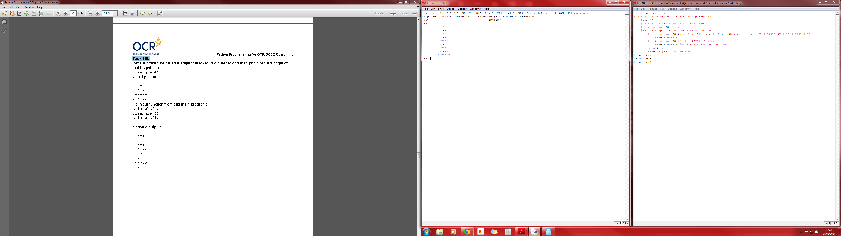



START

How many lines of triangles? = size

TimesLoop is how many times around the loop the program has gone. (eg. First = 1, second time = 2)

Add this many spaces (size-1-timesLoop) +11-(size-1-timesLoop) and store as line

Add this many stars (2\*timesLoop+1) and save on top of line

END

Size = how many lines produced?

Print line